



ADVANCED WORD PROCESSING
(210)
STATE 2021

Production:
Job 1: Report __________ (100 points)
Job 2: Letter __________ (100 points)
Job 3: Table with Borders __________ (100 points)
TOTAL POINTS __________ (300 points)

Test Time: 90 minutes

GENERAL GUIDELINES:
Failure to adhere to any of the following rules will result in disqualification:
- Member must hand in this test booklet and all printouts if any. Failure to do so will result in disqualification.
- No equipment, supplies, or materials other than those specified for this event are allowed in the testing area. No previous BPA tests and/or sample tests (handwritten, photocopied, or keyed) are allowed in the testing area.
- Electronic devices will be monitored according to ACT standards.

EXAM GUIDELINES:
- Ensure this test booklet contains Jobs 1-3.
- Key all jobs according to the instructions given.
- Correct any and all formatting, spelling or grammar errors. Use the formatting guide in the Style & Reference Manual.
- Your name or initials should not appear on any work you submit. Use your contestant number in any occasion you would normally key your reference initials.
- In the lower right hand corner of ALL work submitted (unless otherwise specified), key your Member ID and job number.
- If you complete the event before the end of the time allotted, notify the proctor. Time may be considered a factor in determining a winner when there is a tie score.
- Place your scoring sheet on top of your jobs. Jobs should be placed in numerical order.

PRODUCTION STANDARDS
0 Errors | 100 Points
1 Error | 90 Points
2 Errors | 70 Points
3 Errors | 50 Points
4+ Errors | 0 Points

Job 1: Report (100 points)
Michelle Valdez

Nancy Wells

CEO

Current Date

21st Century Skills

21st century skills comprise skills, abilities, and learning dispositions that have been identified as being required for success in 21st century society and workplaces by educators, business leaders, academics, and governmental agencies.
The current workforce is significantly more likely to change career fields or jobs. Those in the Baby Boom generation entered the workforce with a goal of stability; subsequent generations are more concerned with finding happiness and fulfillment in their work lives. Young workers in North America are now likely to change jobs at a much higher rate than previously, as much as once every 4.4 years on average.
People skills that involve interaction, collaboration, and managing others are increasingly important. The skills have been grouped into three main areas:
- Learning and innovation skills
- Digital literacy skills
- Career and life skills
Many of these skills are also identified as key qualities of progressive education, a pedagogical movement that began in the late nineteenth century and continues in various forms to the present.

Current Date
Job 2: Letter (100 points)

Mrs. Emily Carter, CEO
Perfect Balance Accounting
4032 National Drive
Columbus, OH 43110

Dear Mrs. Carter

LETTER OF RECOMMENDATION

My name is Julie Smith, and I am pleased to offer my recommendation of Walter Harris for the position of Administrative Assistant at Perfect Balance Accounting.

During my relationship with Walter over the past five years, I have experienced a highly motivated, hard-working individual who consistently arrives on time and shows great dedication towards his professional duties. I strongly believe that Walter will be a great addition to your company and will exceed expectations in his role as Administrative Assistant.

I have enclosed our company brochure with additional information about him. Please do not hesitate to contact me if you should require any additional information.

Sincerely

Julie Smith
Human Resources

11-2222-3333

Enclosure
11-2222-3333
Job 2

Current Date

Mrs. Emily Carter, CEO
Perfect Balance Accounting
4032 National Drive
Columbus, OH 43110

Dear Mrs. Carter

LETTER OF RECOMMENDATION

My name is Julie Smith, and I am pleased to offer my recommendation of Jennifer Ballinger for the position of Marketing Manager at Perfect Balance Account.
During my relationship with Jennifer over the past seven years, I have experienced a highly motivated, hard-working individual who consistently arrives on time and shows great dedication towards her professional duties. I strongly believe that Jennifer will be a great addition to your company and will exceed expectations in her role as Market Manager.
I have enclosed our company brochure with additional information about her. Please do not hesitate to contact me if you should require any additional information.

Sincerely

Julie Smith
Human Resources

11-2222-3333

Enclosure
11-2222-3333
Job 2

NOTE TO GRADER: Corrections to be made are highlighted
Job 3: Table (100 points)

DECEMBER PURCHASES

Sales Department

Transaction ID | Payment Date | Product | Quantity | Cost | Total Cost
JDN184 | 12/1/2020 | Desk Calendars | 10 | $3.25 | $ 32.50
MEH974 | 12/5/2020 | #10 Envelopes | 10 | 22.99 | 229.90
IDV227 | 12/5/2020 | Legal Pads | 10 | 15.98 | 159.80
TCN834 | 12/8/2020 | Post It Notes | 12 | 8.75 | 105.00
ODD932 | 12/8/2020 | Paper Clips | 10 | 2.65 | 26.50
SDE648 | 12/8/2020 | Binder Clips | 7 | 4.99 | 34.93
LMD277 | 12/14/2020 | Hanging File Folders | 10 | 12.99 | 129.90
WNF440 | 12/18/2020 | Highlighters | 15 | 2.99 | 44.85
PWS183 | 12/20/2020 | Dry Erase Markers | 20 | 6.79 | 135.80
ADS324 | 12/20/2020 | Pens | 40 | 1.99 | 79.60
Total |  |  | 144 | $83.37 | $978.78

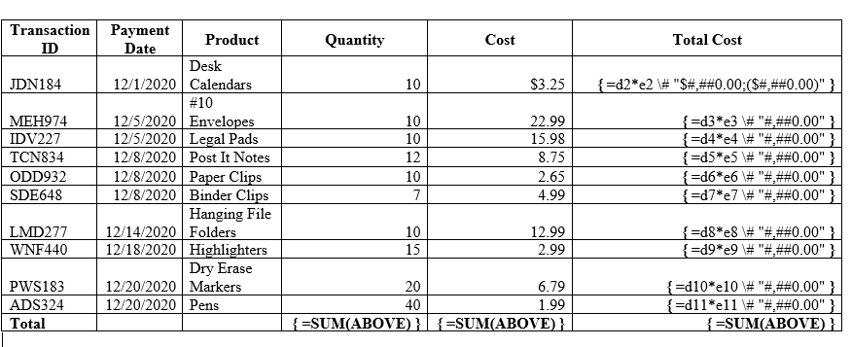
NOTE to GRADER: Must be printed in landscape with formula

